实验十三 雾、透明和阴影
一、实验目的
1. 了解雾的绘制与效果
2．利用OpenGL的Blending和对称功能实现透明效果
3。利用投影变换矩阵可实现阴影效果

二、实验环境
硬件要求：
PC机，主流配置，最好为独立显卡，显存512M以上。
软件环境：
操作系统：Windows 7/10。
语言开发工具：Microsoft Visual studio 2010/2017,Visual C/C++。
三、实验要求与内容：
要求：
- 设计你的3D小场景，同时加上光照材质、雾、透明和阴影效果。
- 撰写实验报告，将效果截图和主程序拷贝到实验报告文档里，提交实验报告：学号姓名-计算机图形学实验报告-lab13.docx。

内容：
- 雾的生成

附属程序rotating torus-fog.cpp为一视点保持不变的3D旋转程序，3D场景为一个圆环、一个小球和一个以四边形为基本单位的方块墙包围盒，且小球和圆环在“方块墙”的包围盒中。视点设在正前方观察物体，小球绕着环心某处不停旋转，并和圆环一起绕着环心不停旋转，并且场景实现了光照材质和雾化效果，参见图1将程序仔细研读，运行查看效果，了解OpenGL雾的设置代码编写。
分别修改雾的颜色、雾的起始距离、雾的模式和雾的密度，观察雾化效果的变化，保存效果截图及其相应参数。

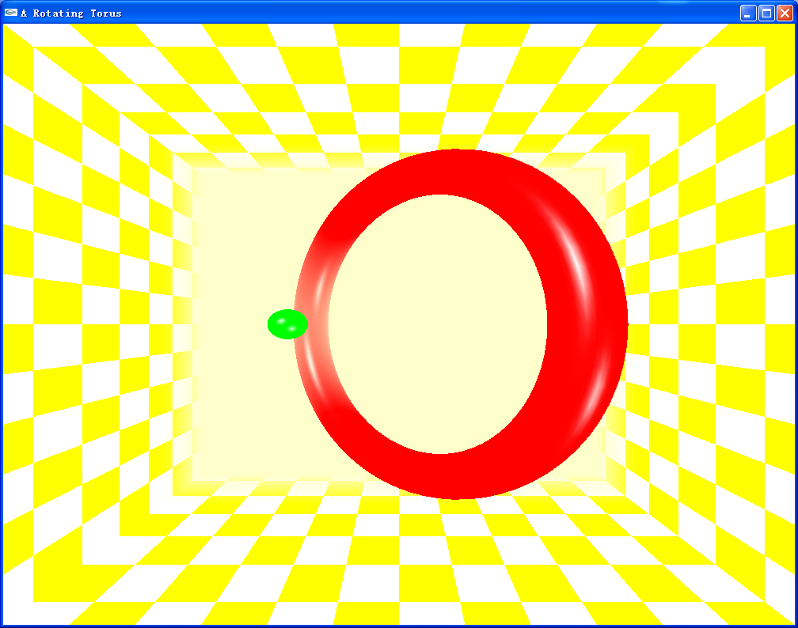
图1 带雾化效果的3D场景

- 透明的效果

附属程序rotating torus-transparency.cpp生成的仍是上述例子所描述的场景。所不同的是在基本光照效果上加上了透明的效果，参见图2。将程序仔细研读，运行查看效果。
分别修改透明度alpha，修改调和因子、调和方式，修改调和颜色，查看透明的效果，保存效果截图及其相应参数。
思考：调和因子与透明度的关系了解OpenGL雾的设置代码编写。
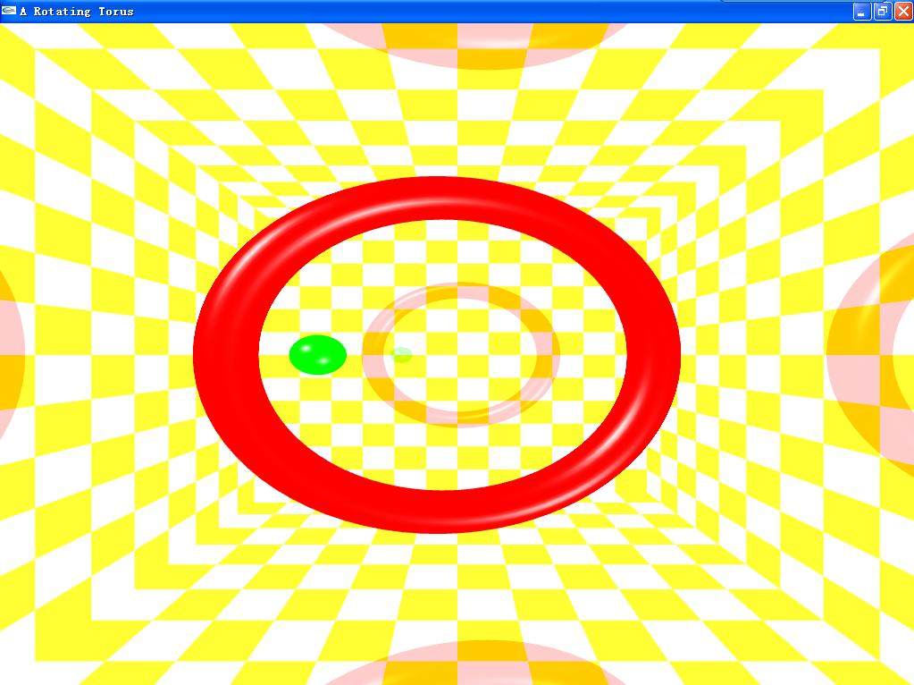
图2 透明效果

- 阴影的效果

附属程序rotating torus-shadow.cpp生成的仍是上述例子所描述的场景，所不同的是在基本光照效果上加上了阴影的效果，参见图3。将程序仔细研读，运行查看效果。
分别阴影色，及其背景透明度alpha值，光源的位置和光照颜色，查看阴影效果，保存效果截图及其相应参数。
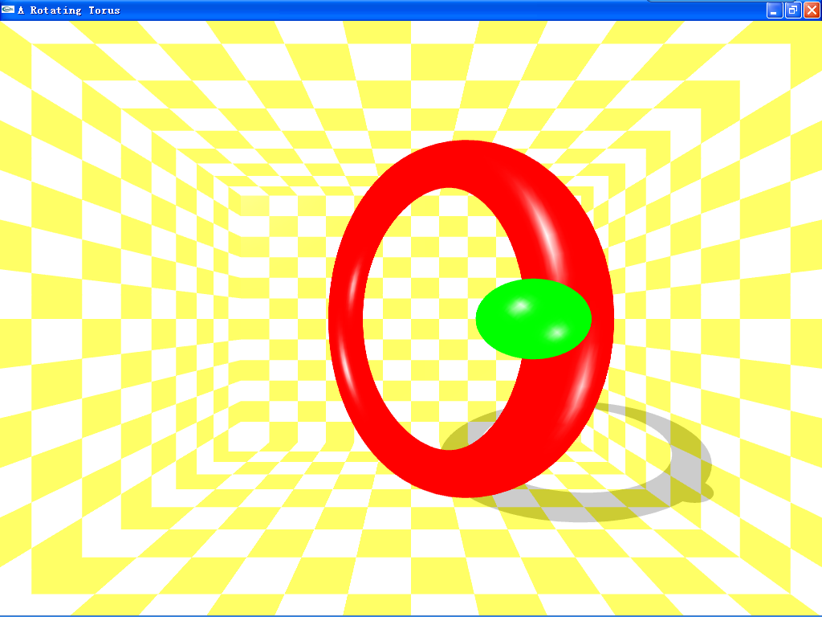
图3 阴影效果

- 透明、雾和阴影综合效果
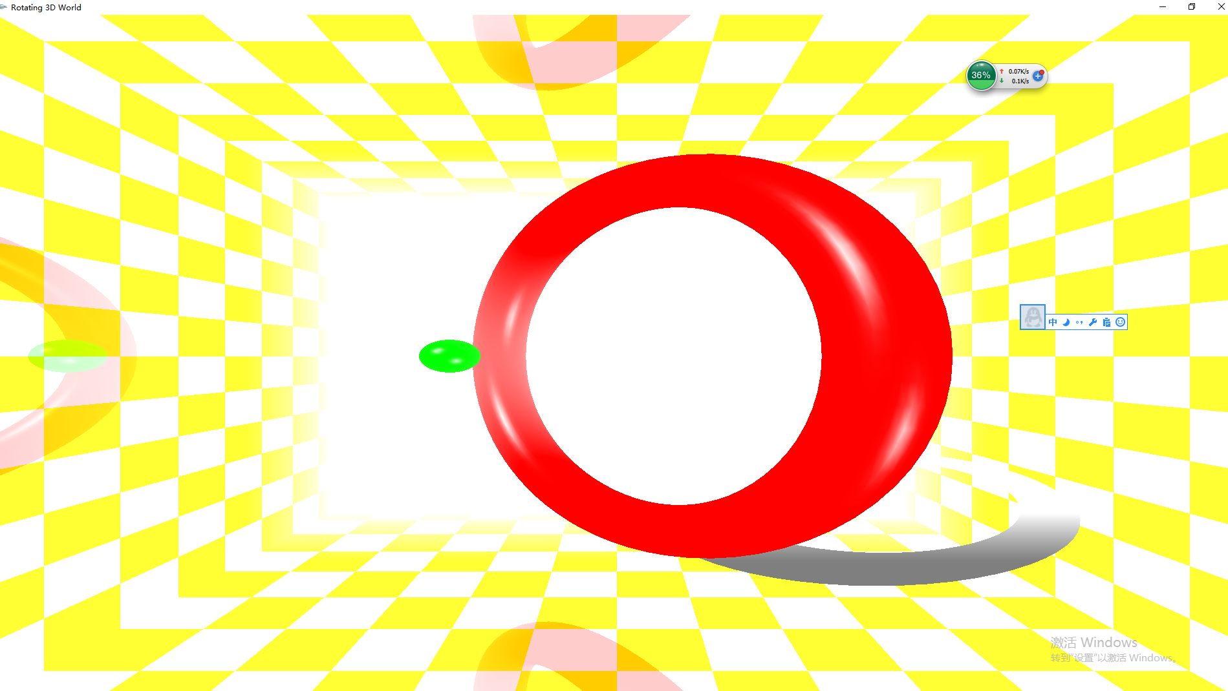
五、函数与设置参考
1) 雾化效果设置函数
- void glFogi (GLenum pname, GLint param);
- void glFogf (GLenum pname, GLfloat param);
- void glFogiv (GLenum pname, GLint* param);
- void glFogfv (GLenum pname, GLfloat* param);
pname—雾气参数类型，包括雾的颜色、雾的浓度、雾的远近和雾的模式等参数类型；
param—相应的参数值
Glint* 表示整数型数组指针，数组里包含了参数值
Glfloat* 表示浮点型数组指针，数组里包含了参数值
例,
glEnable(GL_FOG); //enable fog effect
glFogfv(GL_FOG_COLOR, fogColor); //fog’s color
glFogf(GL_FOG_START, 5.0f); // how far to start
glFogf(GL_FOG_END, 30.f); //how far to end
glFogi（GL_FOG_MODE,GL_LINEAR); //which mode
glFogf(GL_FOG_DENSITY, 0.5f); //fog density

注：
雾化效果必须启用才能有效：
glEnable(GL_FOG); //启用雾气效果
用以下语句关闭雾气效果：glDisable(GL_FOG);
雾的浓度范围：0~1，默认为1
OpenGL支持3种雾方程式：
- GL_LINEAR 线性变化
- GL_EXP 特征曲线变化
- GL_EXP2 指数曲线变化

2）透明设置函数
在OpenGL中使用颜色调和函数来模拟透明效果，使用glMaterial和glColor中的透明参数alpha设置透明度，Alpha取值为0到1之间，0表示完全透明，1表示完全不透明。
但不能直接实现，必须通过调和函数，与其他颜色调和搭配来实现。

调和函数
void glBlendunc(GLenum S, GLenum D);
S-源颜色调和因子
D-目标颜色调和因子
最终颜色效果是通过源颜色和目标颜色调合而成，它们的比例将由其相应的调和因子来决定。

注意必须使用glEnable(GL_BLEND)激活函数glBlendunc(GLenum S, GLenum D)的颜色调和功能

下图为调和因子选项及其含义
调和因子选项 | RGB混合因子 | Alpha混合因子
GL_ZERO | (0,0,0) | 0
GL_ONE | (1,1,1) | 1
GL_SRC_COLOR | (Rs,Gs,Bs) | As
GL_ONE_MINUS_SRC_COLOR | (1,1,1)-(Rs,Gs,Bs) | 1- As
GL_DST_COLOR | (Rd,Gd,Bd) | Ad
GL_ONE_MINUS_DST_COLOR | (1,1,1)-(Rd,Gd,Bd) | 1- Ad
GL_SRC_ALPHA | (As, As, As) | As
GL_ONE_MINUS_SOURCE_ALPHA | (1,1,1)-(As, As, As) | 1- As
GL_DST_ALPHA | (Ad, Ad, Ad) | Ad
GL_ONE_MINUS_DST_ALPHA | (1,1,1)- (Ad, Ad, Ad) | 1- Ad
GL_CONSTANT_COLOR | (Rc, Gc, Bc) | Ac
GL_ONE_MINUS_CONSTANT_COLOR | (1,1,1)- (Rc, Gc, Bc) | 1- Ac
GL_CONSTANT_ALPHA | (Ac, Ac, Ac) | Ac
GL_ONE_MINUS_CONSTANT_ALPHA | (1,1,1)-(Ac, Ac, Ac) | 1- Ac
GL_SRC_ALPHA_STATURE | (f,f,f), f=min(As,1-Ad) | 1

简单透明效果设置步骤：

- 设置镜像光源位置;（可以省略）
- 绘制镜像被透明物体，注意多边形正面设置

- 取消光源Disable(GL_LIGHTING);
- 启用调和 glEnable(GL_BLEND);
- 调用调和函数 glBlendFunc();
- 绘制透明物体;
- 取消调和 glDisable(GL_BLEND);
- 启用光源glEnable(GL_LIGHTING);

- 设置光源位置
- 绘制被透明物体

3） 简单阴影设置步骤：
1．根据光线方向和投影面计算阴影矩阵
2． 将源物体乘上阴影矩阵即得到阴影物体
3． 将阴影物体颜色设为阴影色(暗色调)
4. 将阴影和源物体同时绘出即生成最后效果

请参看阴影附属程序

六、课后作业
设计你的3D小场景，同时加上光照材质、雾、透明和阴影效果。
七、演示程序
1）shadow.exe //阴影效果
2）fog.exe //雾效果
3) transparency.exe //透明效果

八、附属程序
1． 透明程序 rotating torus-transparency.cpp

#include "stdafx.h"
#include <math.h>
#include <glut.h>

#define PI 3.14159

float theta=-90.0; //圆环旋转角
float angle=10; //左右场景每次旋转角
float sightangle=-90;
float s=10; //前后直走步长
float R=100;
int inner=10,outer=80;

float eyex=0,eyey=0,eyez=outer+4*inner+50; //初始视点位置
float atx=0,aty=0,atz=0; //初始目标点位置
float atx1,atz1,eyex1,eyez1;

float tt=0,tt2=0;

// void specialkeyboard(int key, int x, int y);
void mykeyboard(unsigned char key, int x, int y);
void Display(void);
void Reshape(int w, int h);
void myidle();
void drawground();
void drawsphere();
void drawwall();
void init();

int APIENTRY _tWinMain(HINSTANCE hInstance,
HINSTANCE hPrevInstance,
LPTSTR lpCmdLine,
int nCmdShow)
{
UNREFERENCED_PARAMETER(hPrevInstance);
UNREFERENCED_PARAMETER(lpCmdLine);

char *argv[] = { (char*)"hello ", (char*)" " };
int argc = 2; // must/should match the number of strings in argv
glutInit(&argc, argv); //初始化GLUT库；
glutInitDisplayMode(GLUT_DOUBLE | GLUT_RGB); //设置显示模式；（缓冲，颜色类型）
glutInitWindowSize(500, 500);
glutInitWindowPosition(1024 / 2 - 250, 768 / 2 - 250);
glutCreateWindow("Rotating 3D World"); //创建窗口，标题为“Rotating 3D World”；
glutReshapeFunc(Reshape);
init();
glutDisplayFunc(Display); //用于绘制当前窗口；
glutKeyboardFunc(mykeyboard);
glutIdleFunc(myidle);
glutMainLoop(); //表示开始运行程序，用于程序的结尾；

return 0;
}

void init()
{

//define light position1
GLfloat light_position1[]={-outer,outer,outer+inner,0.0};
// GLfloat light_position1[]={0,0,0,0.0};
GLfloat light_position2[]={+outer,-outer,outer+inner,0.0};

//GLfloat light color1
GLfloat light_ambient1[]={1.0,1.0,1.0,1.0};
GLfloat light_diffuse1[]={1.0,1.0,1.0,1.0};
GLfloat light_specular1[]={1.0,1.0,1.0,1.0};

//GLfloat light color2
GLfloat light_ambient2[]={0.8,0.8,0.8,1.0};
GLfloat light_diffuse2[]={0.8,0.8,0.8,1.0};
GLfloat light_specular2[]={0.8,0.8,0.8,1.0};

// light model- global light
GLfloat lmodel_ambient[]={0.8,0.2,0.2,1.0};
glLightModelfv(GL_LIGHT_MODEL_AMBIENT, lmodel_ambient);
glLightModeli(GL_LIGHT_MODEL_LOCAL_VIEWER,GL_TRUE);

// set light source location
glLightfv(GL_LIGHT0,GL_POSITION,light_position1);
glLightfv(GL_LIGHT1,GL_POSITION,light_position2);

// set light source color;
glLightfv(GL_LIGHT0,GL_AMBIENT,light_ambient1);
glLightfv(GL_LIGHT0,GL_DIFFUSE,light_diffuse1);
glLightfv(GL_LIGHT0,GL_SPECULAR,light_specular1);

// set light source color;
glLightfv(GL_LIGHT1,GL_AMBIENT,light_ambient2);
glLightfv(GL_LIGHT1,GL_DIFFUSE,light_diffuse2);
glLightfv(GL_LIGHT1,GL_SPECULAR,light_specular2);

// set material let material fits color
glEnable(GL_COLOR_MATERIAL);
glColorMaterial(GL_FRONT,GL_AMBIENT_AND_DIFFUSE);

//make light source enable;
glEnable(GL_LIGHTING);
glEnable(GL_LIGHT0);
glEnable(GL_LIGHT1);

//clear color
glClearColor(0.0,0.0,0.0,0.0);

//Color shade mode
glShadeModel(GL_SMOOTH);

// polygon mode
glPolygonMode(GL_FRONT,GL_FILL);

// Anti-aliasing
/* glEnable(GL_POINT_SMOOTH);
glHint(GL_POINT_SMOOTH_HINT, GL_NICEST);
glEnable(GL_LINE_SMOOTH);
glHint(GL_LINE_SMOOTH_HINT, GL_NICEST);
glEnable(GL_POLYGON_SMOOTH);
glHint(GL_POLYGON_SMOOTH_HINT, GL_NICEST);*/

// glEnable(GLUT_MULTISAMPLE);
// depth detecting
glEnable(GL_DEPTH_TEST);

}

void Display(void)
{

glClearColor(1,1,1,1);
// glClear(GL_COLOR_BUFFER_BIT);

glClear(GL_COLOR_BUFFER_BIT|GL_DEPTH_BUFFER_BIT);

glMatrixMode(GL_MODELVIEW);
glLoadIdentity();

// gluLookAt(0,-10,350,0,0,0,0,1,0);

gluLookAt(eyex,eyey,eyez,atx,aty,atz,0,1,0);

//about ground
glPushMatrix();
glFrontFace(GL_CW);
glTranslatef(0,-outer-4*inner,0);
glScalef(1.0f,-1.0f,1.0f);
glTranslatef(0,outer+4*inner,0);
drawsphere();
glFrontFace(GL_CCW);
glPopMatrix();

//about top
glPushMatrix();
glFrontFace(GL_CW);
glTranslatef(0,+outer+4*inner,0);
glScalef(1.0f,-1.0f,1.0f);
glTranslatef(0,-outer-4*inner,0);
drawsphere();
glFrontFace(GL_CCW);
glPopMatrix();

//about right wall
glPushMatrix();
glFrontFace(GL_CW);
glTranslatef(+outer+4*inner,0,0);
glScalef(-1.0f,1.0f,1.0f);
glTranslatef(-outer-4*inner,0,0);
drawsphere();
glFrontFace(GL_CCW);
glPopMatrix();

//about left wall
glPushMatrix();
glFrontFace(GL_CW);
glTranslatef(-outer-4*inner,0,0);
glScalef(-1.0f,1.0f,1.0f);
glTranslatef(+outer+4*inner,0,0);
drawsphere();
glFrontFace(GL_CCW);
glPopMatrix();

//about front wall
glPushMatrix();
glFrontFace(GL_CW);
glTranslatef(0,0,-outer-4*inner);
glScalef(1.0f,1.0f,-1.0f);
glTranslatef(0,0,outer+4*inner);
drawsphere();
glFrontFace(GL_CCW);
glPopMatrix();

glDisable(GL_LIGHTING);
glEnable(GL_BLEND);
glBlendFunc(GL_SRC_ALPHA,GL_ONE_MINUS_SRC_ALPHA);
drawground();
drawwall();
glDisable(GL_BLEND);
glEnable(GL_LIGHTING);

drawsphere();

glutSwapBuffers();
// glFlush();
}

void drawsphere()
{

float tr;
tr=(outer+3*inner);

glRotatef(theta,0,1,0);

glPushMatrix();
glPushMatrix();
glColor3f(1.0,0,0.0);
glutSolidTorus(inner,outer,50,80);
glPopMatrix();

glPushMatrix();
glTranslatef(outer,0,0);
glRotatef(theta,0,1,0);
glTranslatef(-outer,0,0);

glPushMatrix();
glTranslatef(tr,0,0);
glRotatef(-45,1,0,0);
glColor3f(0.0,1.0,0);
glutSolidSphere(inner,40,40);
glPopMatrix();
glPopMatrix();
glPopMatrix();

}

void drawground()
{

int colorflag=1;

GLfloat mat_specular1[]={1.0,1.0,1.0,1.0};
GLfloat mat_shininess1[]={80.0};
glMaterialfv(GL_FRONT,GL_SPECULAR,mat_specular1);
glMaterialfv(GL_FRONT,GL_SHININESS,mat_shininess1);

glNormal3f(0,1,0);
for (int i=-outer-4*inner;i<outer+4*inner;i+=2*inner)
{
if (colorflag>0) glColor4f(1.0,1.0,0.0,0.8);
else glColor4f(1.0,1.0,1.0,0.8);

colorflag=-colorflag;

for (int j=-outer-4*inner;j<outer+4*inner;j+=2*inner)
{
if (colorflag>0) glColor4f(1.0,1.0,0.0,0.8);
else glColor4f(1.0,1.0,1.0,0.8);

colorflag=-colorflag;
glBegin(GL_QUADS);
glVertex3d(j,-outer-4*inner,i);
glVertex3d(j,-outer-4*inner,i+2*inner);
glVertex3d(j+2*inner,-outer-4*inner,i+2*inner);
glVertex3d(j+2*inner,-outer-4*inner,i);
glEnd();
}
}

glNormal3f(0,-1,0);
colorflag=1;

for ( int i=-outer-4*inner;i<outer+4*inner;i+=2*inner)
{
if (colorflag>0) glColor4f(1.0,1.0,0.0,0.8);
else glColor4f(1.0,1.0,1.0,0.8);

colorflag=-colorflag;

for (int j=-outer-4*inner;j<outer+4*inner;j+=2*inner)
{
if (colorflag>0) glColor4f(1.0,1.0,0.0,0.8);
else glColor4f(1.0,1.0,1.0,0.8);

colorflag=-colorflag;
glBegin(GL_QUADS);
glVertex3d(j,outer+4*inner,i);
glVertex3d(j,outer+4*inner,i+2*inner);
glVertex3d(j+2*inner,outer+4*inner,i+2*inner);
glVertex3d(j+2*inner,outer+4*inner,i);
glEnd();
}
}

}

void drawwall()
{
int i,j;

glNormal3f(1,0,0);

int colorflag=1;

//left
for (i=-outer-4*inner;i<outer+4*inner;i+=2*inner)
{
if (colorflag>0) glColor4f(1.0,1.0,0.0,0.8);
else glColor4f(1.0,1.0,1.0,0.8);

colorflag=-colorflag;

for (j=-outer-4*inner;j<outer+4*inner;j+=2*inner)
{
if (colorflag>0) glColor4f(1.0,1.0,0.0,0.8);
else glColor4f(1.0,1.0,1.0,0.8);

colorflag=-colorflag;

glBegin(GL_QUADS);
glVertex3d(-outer-4*inner,j,i);
glVertex3d(-outer-4*inner,j+2*inner,i);
glVertex3d(-outer-4*inner,j+2*inner,i+2*inner);
glVertex3d(-outer-4*inner,j,i+2*inner);
glEnd();
}
}

colorflag=1;

glNormal3f(0,-1,0);

//right
for (i=-outer-4*inner;i<=outer+4*inner-2*inner;i+=2*inner) //for z
{
if (colorflag>0) glColor4f(1.0,1.0,0.0,0.8);
else glColor4f(1.0,1.0,1.0,0.8);

colorflag=-colorflag;

for (j=-outer-4*inner;j<=outer+4*inner-2*inner;j+=2*inner) //for y
{
if (colorflag>0) glColor4f(1.0,1.0,0.0,0.8);
else glColor4f(1.0,1.0,1.0,0.8);

colorflag=-colorflag;

glBegin(GL_QUADS);
glVertex3f(outer+4*inner,j,i);
glVertex3f(outer+4*inner,j+2*inner,i);
glVertex3f(outer+4*inner,j+2*inner,i+2*inner);
glVertex3f(outer+4*inner,j,i+2*inner);
glEnd();

}
}

colorflag=1;

glNormal3f(0,0,1);

//front
for (i=-outer-4*inner;i<=outer+4*inner-2*inner;i+=2*inner) //for z
{
if (colorflag>0) glColor4f(1.0,1.0,0.0,0.8);
else glColor4f(1.0,1.0,1.0,0.8);

colorflag=-colorflag;

for (j=-outer-4*inner;j<=outer+4*inner-2*inner;j+=2*inner) //for y
{
if (colorflag>0) glColor4f(1.0,1.0,0.0,0.8);
else glColor4f(1.0,1.0,1.0,0.8);

colorflag=-colorflag;

glBegin(GL_QUADS);
glVertex3f(j,i,-outer-4*inner);
glVertex3f(j+2*inner,i,-outer-4*inner);
glVertex3f(j+2*inner,i+2*inner,-outer-4*inner);
glVertex3f(j,i+2*inner,-outer-4*inner);
glEnd();

}
}

}

void myidle()
{

theta+=0.5;
// if (theta>=360.0) theta-=360.0;
glutPostRedisplay();
}

void Reshape(GLsizei w,GLsizei h)
{
glMatrixMode(GL_PROJECTION);
glLoadIdentity();
// glOrtho(-outer-6*inner,outer+6*inner,-outer-4*inner,outer+4*inner,20,2*outer+8*inner+50);
gluPerspective(90,w/h,10,2*outer+8*inner+250);
glViewport(0,0,w,h);
glMatrixMode(GL_MODELVIEW);

}

void mykeyboard(unsigned char key, int x, int y)
{

switch(key)
{
case 'W':
case 'w':// 向前走

eyex1=eyex-s*sin(sightangle*2*PI/360-PI/2);
eyez1=eyez-s*cos(sightangle*2*PI/360-PI/2);

atx1=atx-s*sin(sightangle*2*PI/360-PI/2);
atz1=atz-s*cos(sightangle*2*PI/360-PI/2);

eyex=eyex1;
eyez=eyez1;

atz=atz1;
atx=atx1;

break;
case 'S':
case 's'://向后走
eyex1=eyex+s*sin(sightangle*2*PI/360-PI/2);
eyez1=eyez+s*cos(sightangle*2*PI/360-PI/2);

atx1=atx+s*sin(sightangle*2*PI/360-PI/2);
atz1=atz+s*cos(sightangle*2*PI/360-PI/2);

eyex=eyex1;
eyez=eyez1;

atz=atz1;
atx=atx1;
break;
case 'A':
case 'a'://左转
/* atx1=eyex+(atx-eyex)*cos(angle*2*PI/360.0)+(eyez-atz)*sin(angle*2*PI/360.0);
atz1=eyez-(eyez-atz)*sin(angle*2*PI/360.0)+(atx-eyex)*cos(angle*2*PI/360.0);*/

atx1=eyex+(atx-eyex)*cos(angle*2*PI/360.0)+(eyez-atz)*sin(angle*2*PI/360.0);
atz1=eyez-(eyez-atz)*cos(angle*2*PI/360.0)-(-atx+eyex)*sin(angle*2*PI/360.0);

atx=atx1;
atz=atz1;

sightangle=sightangle+angle;

break;
case 'D':
case 'd'://右转
/*atx1=eyex+(atx-eyex)*cos(-angle*2*PI/360.0)+(eyez-atz)*sin(-angle*2*PI/360.0);
atz1=eyez-(eyez-atz)*sin(-angle*2*PI/360.0)+(atx-eyex)*cos(-angle*2*PI/360.0);*/

atx1=eyex+(atx-eyex)*cos(angle*2*PI/360.0)-(eyez-atz)*sin(angle*2*PI/360.0);
atz1=eyez-(eyez-atz)*cos(angle*2*PI/360.0)+(-atx+eyex)*sin(angle*2*PI/360.0);

atx=atx1;
atz=atz1;

sightangle=sightangle-angle;

break;
}
//参数修改后调用重画函数，屏幕图形将发生改变
glutPostRedisplay();
}

- 雾化程序修改
在init函数中增加以下代码：
GLfloat fogColor[]={1,1,1,1};
glFogfv(GL_FOG_COLOR, fogColor); //fog’s color
glFogf(GL_FOG_START, 200.0f); // how far to start
glFogf(GL_FOG_END, 260.0f); //how far to end
glFogi(GL_FOG_MODE,GL_LINEAR); //which mode
glFogf(GL_FOG_DENSITY, 0.5f);
glEnable(GL_FOG);

3.阴影程序修改
阴影程序除主阴影程序外，还需在工程文件中添加几个辅助程序，参见文件夹
(1) GLTools.h //工具头文件
(2) MatrixMath.cpp //有关矩阵运算
(3)VectorMath.cpp //有关数学公式，如平面方程等
在解决方案资源管理器添加现有项
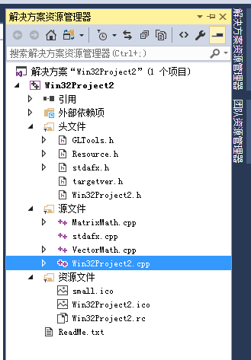

(4）主程序修改：
1). 头部添加代码 #include "GLTools.h"
2）小球函数声明修改 void drawsphere(int flag)
3）添加阴影矩阵和平面上三个点变量声明
GLTMatrix mShadowMatrix;
GLTVector3 vPoints[3] = {{ 0.0f, -outer-4*inner, 0.0f },
{ 10.0f, -outer-4*inner, 0.0f },
{ 5.0f, -outer-4*inner, -5.0f }};

（5）小球绘制函数改为
void drawsphere(int flag)
{
float tr;
tr=(outer+3*inner);
glRotatef(theta,0,1,0);

glPushMatrix();
glPushMatrix();
if (flag==1)
glColor3f(1.0,0,0.0);
else
glColor3f(0.5,0.5,0.5);
glutSolidTorus(inner,outer,50,80);
glPopMatrix();

glPushMatrix();
glTranslatef(outer,0,0);
glRotatef(theta,0,1,0);
glTranslatef(-outer,0,0);

glPushMatrix();
glTranslatef(tr,0,0);
glRotatef(-45,1,0,0);
if (flag==1)
glColor3f(0.0,1.0,0);
else
glColor3f(0.5,0.5,0.5);
glutSolidSphere(inner,40,40);
glPopMatrix();
glPopMatrix();
glPopMatrix();

}

(6）在初始化设置函数 init中添加计算机阴影变换矩阵代码：
gltMakeShadowMatrix(vPoints,light_position1,mShadowMatrix);

(7）绘制函数display中画源物体小球函数都改为
drawsphere(1);

(8）绘制函数display中增加阴影绘制（先画阴影 后画源物体）
// Draw shadows first
glDisable(GL_DEPTH_TEST);
glDisable(GL_LIGHTING);
glPushMatrix();
glMultMatrixf(mShadowMatrix);
drawsphere(0);
glPopMatrix();
glEnable(GL_LIGHTING);
glEnable(GL_DEPTH_TEST);

